EXPERIMENT – 22.

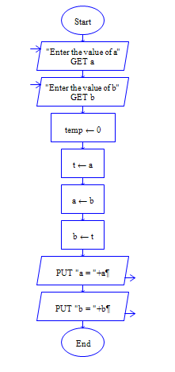

Output:

